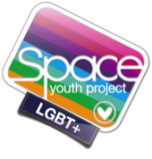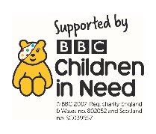**How to talk about LGBT+ Equality with Young People**

**What does LGBT+ mean?**

LGBT+ describes who someone feels they are (their gender) and who they love (their sexuality). The letters stand for lesbian, gay, bisexual and transgender. The plus means that there are many different ways people might describe themselves. You don’t need to know them all.

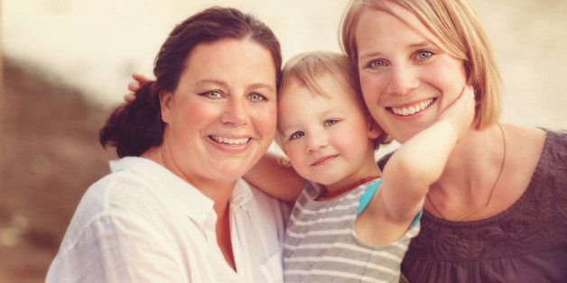**How do I explain what ‘gay’ means?**

Gay means ‘a man who loves a man’ (and is sometimes used to describe a woman who loves a woman), lesbian means ‘a woman who loves a woman’ and bisexual means a person who might love a man or a woman. These are all words that everyone can use, so long as they are used kindly.

**I’ve heard ‘gay’ used as an insult**

Being gay is just another way of being a human. Using ‘gay’ as an insult or to mean something is rubbish can cause long-term damage to someone who grows up to be gay or has gay family members.

**How do I explain why a child in the class has two mums or two dads?**

Some families have one parent, some have adoptive parents, some children live with their grandparents and some children have two mums or two dads. All families are different, but all share the same love.

**Can two men or two women get married?**

Yes, in the UK two men or two women can choose to get married when they are adults.

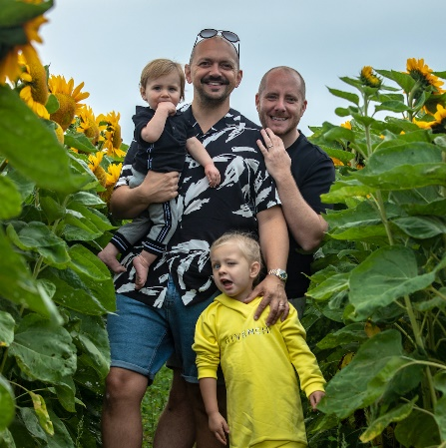

**How do I explain how two men have a baby?**

In lots of families people have babies in different ways. Lots of families, including with two dads, adopt or foster young people. However babies become part of a family, they are loved and cared for in the same ways.

**How do people become gay/ trans?**

People don’t become gay/ trans, they are born gay/trans, but may not realise it for a while. People realise at different ages – sometimes in primary school (or earlier) and sometimes when they are older. It’s just something you know about yourself, like being right- or left-handed

**Our religion says it is wrong to be gay**

Following your religion is important, but it is not alright to treat people badly because they are gay. Religion does not teach us that it is OK to be unkind to people. In the UK, we respect and value people even if they are not the same as us. LGBT+ people are part of life in the UK and young people will grow up to live in this diverse society. It is important that people hear about people who may be different from them.

**What does trans/transgender mean?**

When a person is born they are given a biological sex – male or female, depending on their body. For a few people, as they get older, they notice that their biological sex doesn’t match who they feel/ know they are inside. For example someone born with a girl’s body may realise they are a boy. We are used to thinking that our bodies tell us whether we are a boy or a girl, but this isn’t always the case. Cisgender (or cis) means someone who is not transgender – someone who feels that their biological sex and who they feel they are, match

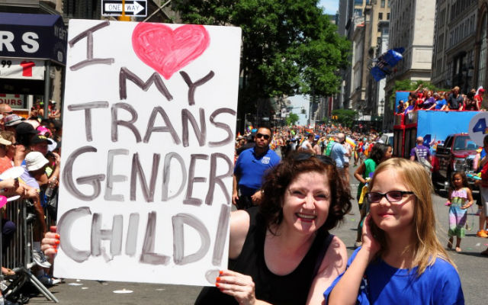

**Is it bad to be transgender?**

No, it isn’t bad – it’s just another way of being a person. Sometimes people make fun of trans people because they don’t understand. It is unkind (and against the law) to bully someone because they are trans

**Are girls who like ‘boys’ things transgender?**

Some girls like traditionally boy things and some boys like traditionally girls things. This does not make them transgender. Gender is something we just know about ourselves, like being left- or right-handed.

**I’m worried my child will be turned gay or trans if they learn about it**

It isn’t possible to turn someone gay or trans. Children and adults are who they are. As parents and carers, the best thing we can do for them is to support them, whoever they are.

**Support and Advice**

**Space Youth Project** [www.spaceyouthproject.co.uk](http://www.spaceyouthproject.co.uk) 01202 205279 07973 405280

*Free, Dorset-based youth groups for LGBT+ and questioning young people; 1:1 support for young people and advice and support for parents*

**Mermaids** [www.mermaids.org.uk](http://www.mermaids.org.uk)0808 801 0400 Mon-Fri 9am-9pm

*Support for transgender, non-binary and gender-diverse young people, empowering them with online communities, groups, helpline services, events and residential weekends.*